1. 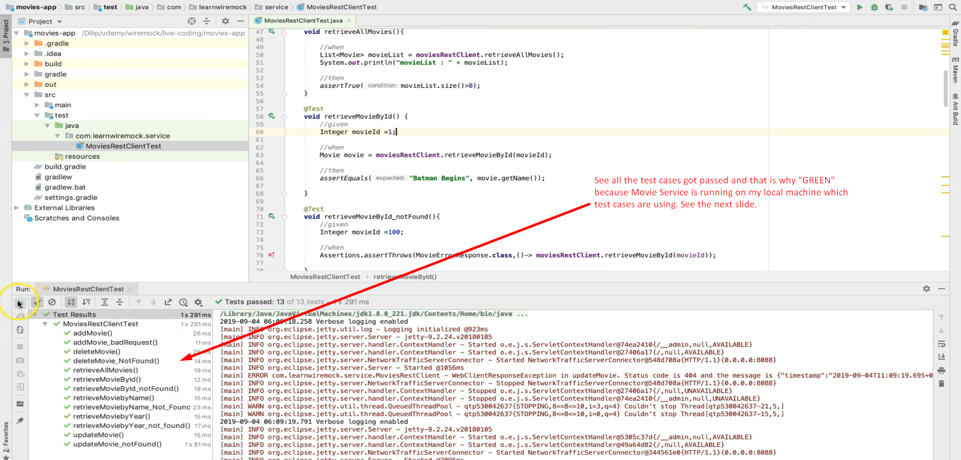
2. 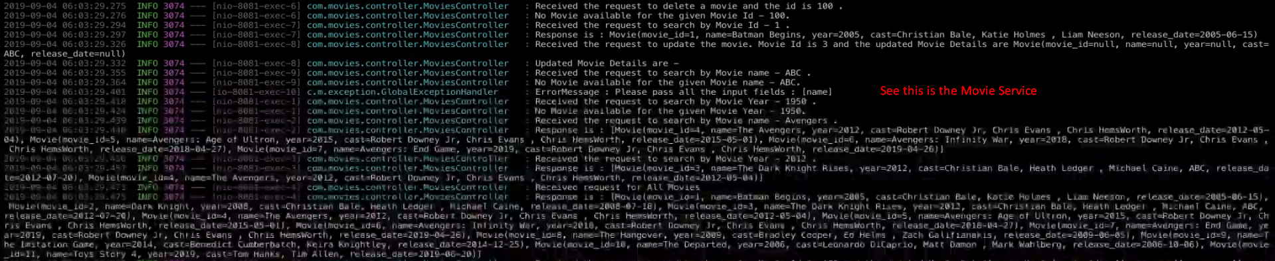**NOTE**: The Movie REST Service is running on localhost:8080  
   **NOTE**: We will run **WireMock Server** at localhost:8088
3. Let’s stop this Movie Service and try to re-run the test cases.
4. 
5. 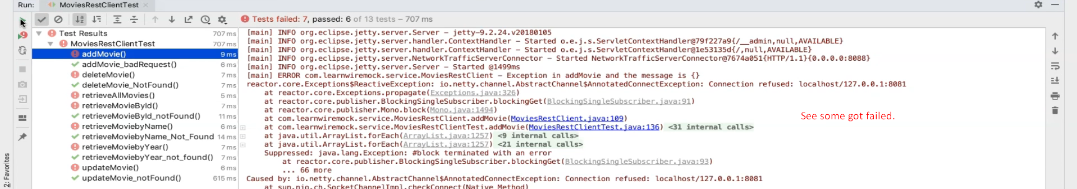
6. The goal is all the test cases should pass as earlier even though Movie Rest Service is not working.
7. Let’s create very first Stub.
   1. but don’t worry about how to add stubs into the WireMock and how WireMock responds to HTTP Requests using those stubs.  
      We will talk about these internal details in a separate lecture.
8. 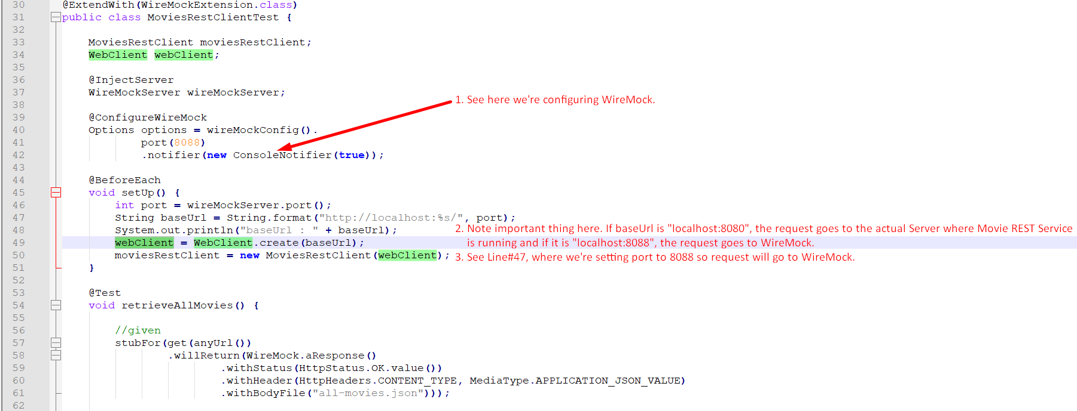
9. Graphical user interface, application, Word

   Description automatically generated